**How to Strengthen OT Cybersecurity for IIoT Environments**

The rise of IIoT in OT/ICS environments enhances efficiency but expands cybersecurity risks. SyskeyOT offers tailored tools for real-time visibility, threat detection, and asset protection. Secure your industrial infrastructure with SyskeyOT's specialized OT cybersecurity solutions.

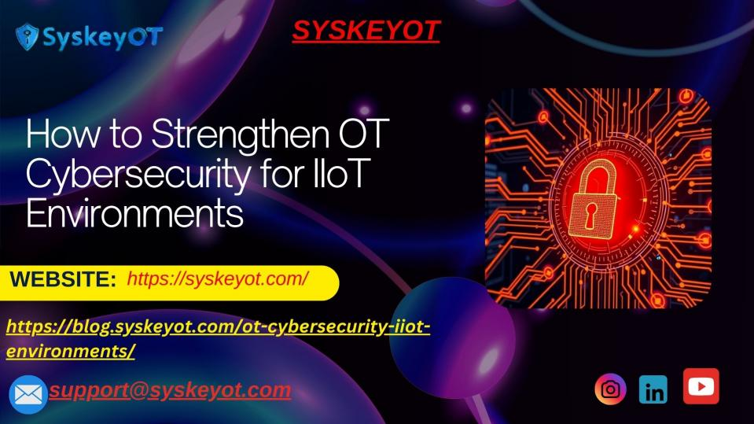

**To know more about:**

**<https://blog.syskeyot.com/ot-cybersecurity-iiot-environments/>**